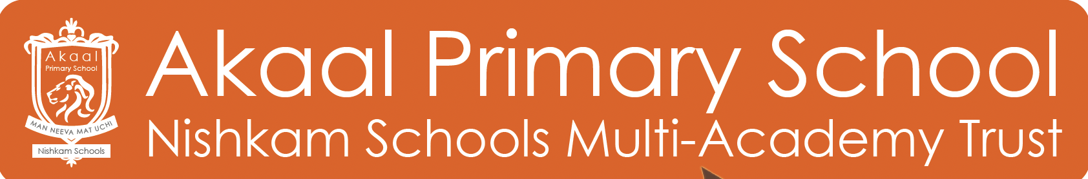

**KS2 Classroom Teacher**

**Post Title:** Classroom Teacher

**Dates:**  Job to start September 2024

**Salary:**  In line with Main Pay Scale

**Location:** Derby

**Contract type:** Full Time

**Contract term:** Fixed Term

Are you a dedicated, enthusiastic teacher who is excited about the prospect of shaping the future of a growing school? Do you want to join a school aspiring for excellence? <https://www.nishkamschooltrust.org/aps/> Have you the vision, commitment and drive to help us continue to develop and deliver the best provision for every child? Why not visit our Facebook page <https://www.facebook.com/akaalps/> or our website <https://www.nishkamschooltrust.org/page/?title=Vacancies&pid=86> to find out more about us.

We welcome applications from practitioners who will:

* Model and disseminate high quality teaching pedagogy and practice to secure consistently good or outstanding teaching and learning for our children;
* Be committed to on-going professional development;
* Contribute to the wider life at the school;
* Maintain a dynamic and inspiring learning environment;
* Be innovative, highly motivated and eager to take a lead;
* Have good interpersonal skills and are able to work well as part of our team.

***The School*** The core of a Nishkam education is the triple pursuit of: academic **excellence**, the development of a **learning community** that supports children throughout their lives and a strong **values-led approach to life**, which is nurtured and supported throughout and beyond the curriculum.

Our children are a delight to teach, and fully engaged in their values-led education. The School and Trust is exceptionally well-resourced with enthusiastic and hardworking staff, and the support team dedicated to the wellbeing of all pupils.

***The Role*** This is a unique and exciting opportunity to be a part of a team that will be shaping this new school . Opportunities like these will be few and far between and will interest those with creative minds, seeking to inspire a new generation of children by embedding core values in every aspect of learning. The position will also be suitable for an NQT, we have an excellent induction programme.

***The successful candidate will be:***

* an exemplary Class Teacher
* a learner committed to professional development and improvement
* committed to and able to support the School ethos
* able promote high standards of attainment and behaviour
* inspirational, enthusiastic and highly motivated
* able to work as part of a team and take individual lead as appropriate
* able to inspire and appreciate creativity
* able to plan and prepare lessons appropriate to the class and individuals
* able to set and assess work to achieve individual progression and whole school improvement
* experienced in promoting the wellbeing of pupils, providing guidance and support
* able to communicate and consult with parents, and prepare reports

***We will offer you:***

* a very warm and welcoming team
* excellent teacher pathways, membership to The Charter College
* hardworking and dedicated colleagues who are prepared to give selflessly for the benefit of the students
* supportive parents, carers and community
* a committed and fully involved Governing Body and Board of Directors
* a well-resourced learning environment
* wide-ranging opportunities for professional development
* collaboration with, and support from, schools across the Trust
* terms and conditions similar to other academies and schools
* a strong commitment and innovative approach to staff wellbeing

We encourage you to visit the school to take the opportunity to learn more about us before deciding to apply. Please contact the school if you would like to attend.

**Nishkam School Trust (NST) is committed to safeguarding and promoting the welfare of children and young people and expects all staff and volunteers to share in this commitment. Any successful applicant will be required to undertake an Enhanced DBS check.**

**The post is exempt from the Rehabilitation of Offenders Act 1974 and the Trust is therefore permitted to ask job applicants to declare all convictions and cautions (including those which are ‘spent’ unless they are ‘protected’ under the DBS filtering rules) in order to assess their suitability to work with children.**

***To Apply:***

* You need to complete an application form, <https://nishkamschooltrust.face-ed.co.uk/vacancies> by **Friday 10th May at 12pm.** Please note, only shortlisted candidates will be contacted to attend an interview.
* Interview: **W/C 27th May 2024.**